192524081 – DANIEL SAM K.

- ANALYSIS DEVELOPMENT AND VERICATION OF 8 BIT & 16 BIT ARITHMETIC OPERATIONS USING ASSEMBLY LANGUAGE PROGRAM

OBJECTIVES
- To develop and verify assembly language programs for performing 8-bit addition and subtraction using the 8085 microprocessor and observe the results stored in memory.
- To develop and verify assembly language programs for performing 16-bit addition and subtraction using the 8085 microprocessor and analyze the results obtained.
- To develop and verify assembly language programs for performing 8-bit multiplication and division using the 8085 microprocessor and check the accuracy of the results.
- To develop and verify assembly language programs for performing 16-bit multiplication and division using the 8085 microprocessor and validate the results obtained through memory locations.

COMPONENTS REQUIRED
- 8085 Simulator OR 8085 Microprocessor

PROCEDURE
- Open the 8085 microprocessor simulator software.
- Write and enter the assembly language programs for 8-bit and 16-bit
addition, subtraction, multiplication, and division.
- Store the input values in the specified memory locations.
- Execute the programs and observe the arithmetic operations performed by the microprocessor.
- Check the results stored in the specified memory locations.
- Verify the results by comparing them with the expected mathematical outputs.

- verify assembly language programs for performing 8-bit addition and subtraction using the 8085 microprocessor and observe the results stored in memory.

8 BIT ADDITION :
MVI C 00h
LDA 4200h
MOV B A
LDA 4201h
ADD B
JNC SKIP
INR C
SKIP: STA 4202h
MOV A C
STA 4203h
HLT

OUTPUT

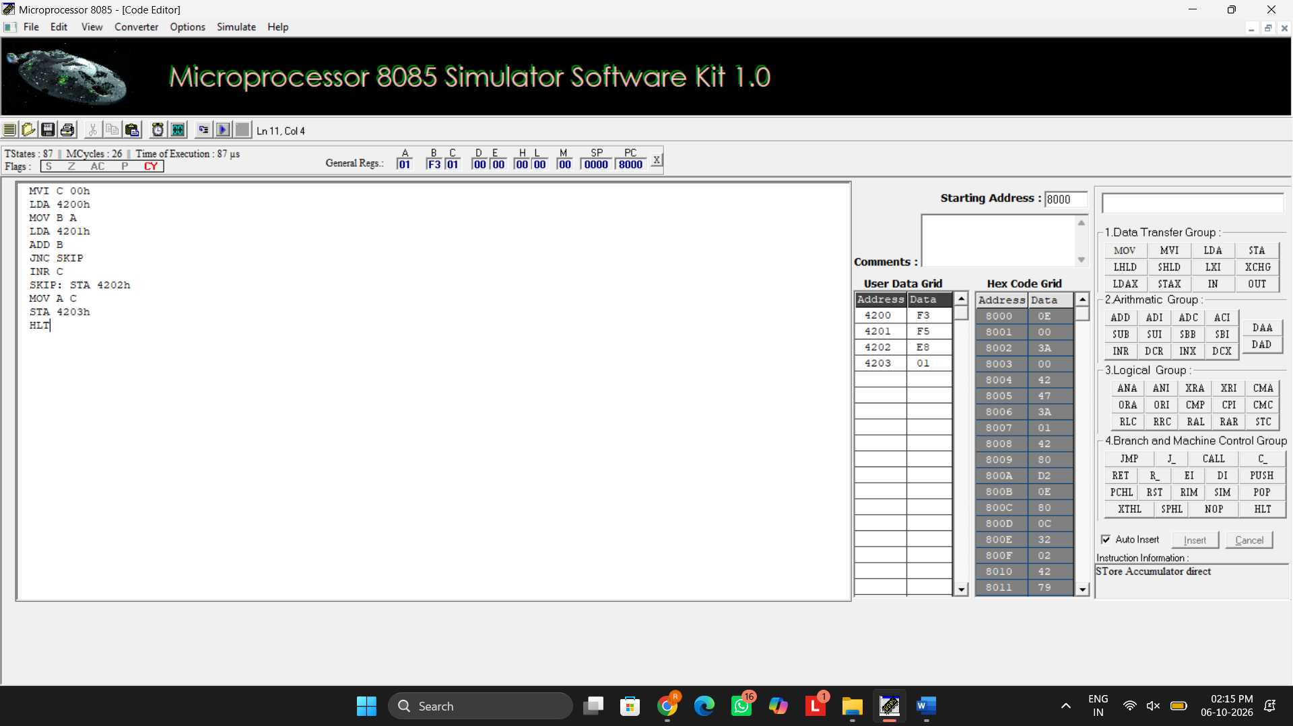
8 BIT SUBRACTION :
MVI C 00h
LDA 4201h
MOV B A
LDA 4200h
SUB B
JNC SKIP
CMA
INR A
INR C
SKIP: STA 4202h
MOV A C
STA 4203h
HLT

OUTPUT
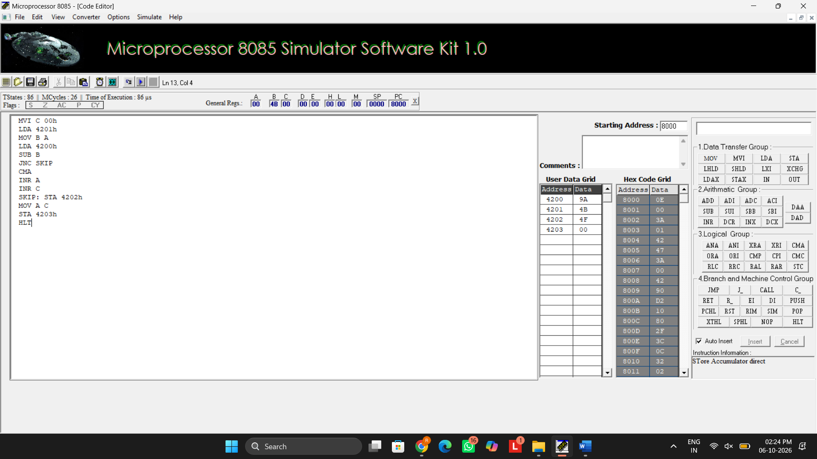

- verify assembly language programs for performing 8-bit multiplication and division using the 8085 microprocessor and check the accuracy of the results.

8 BIT MULTIPLICATION:
LDA 4201h
MOV E A
LDA 4202h
MOV C A
REPEAT: DAD D
DCR C
JNZ REPEAT
SHLD 4203h
HLT
OUTPUT
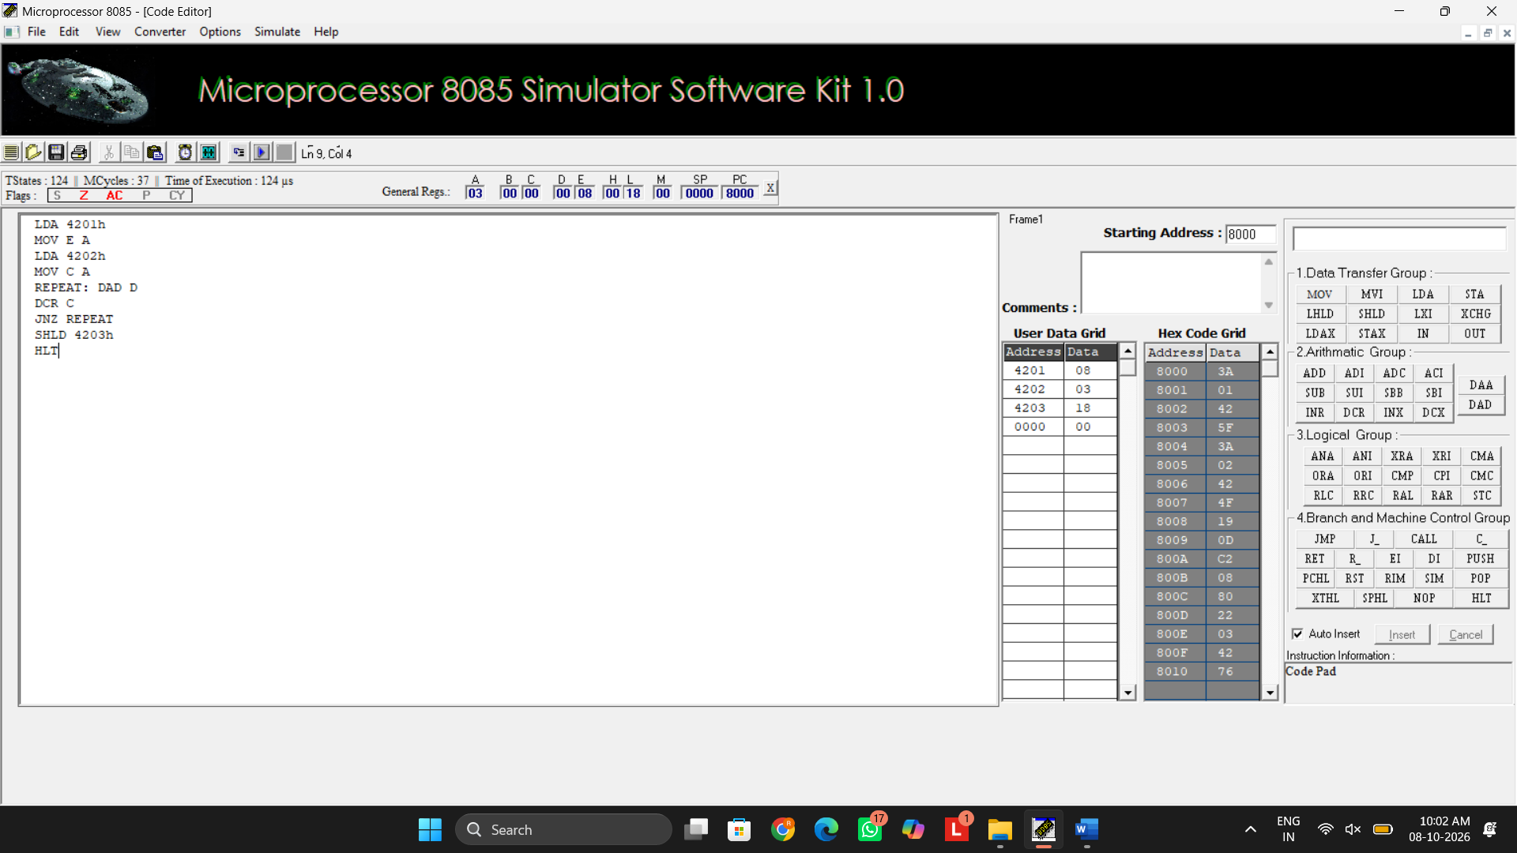
8 BIT DIVISION:
LDA 4201h
MOV B A
LDA 4200h
MVI C 00h
AGAIN: CMP B
JC STORE
SUB B
INR C
JMP AGAIN
STORE: STA 4203
MOV A C
STA 4202h
HLT

OUTPUT
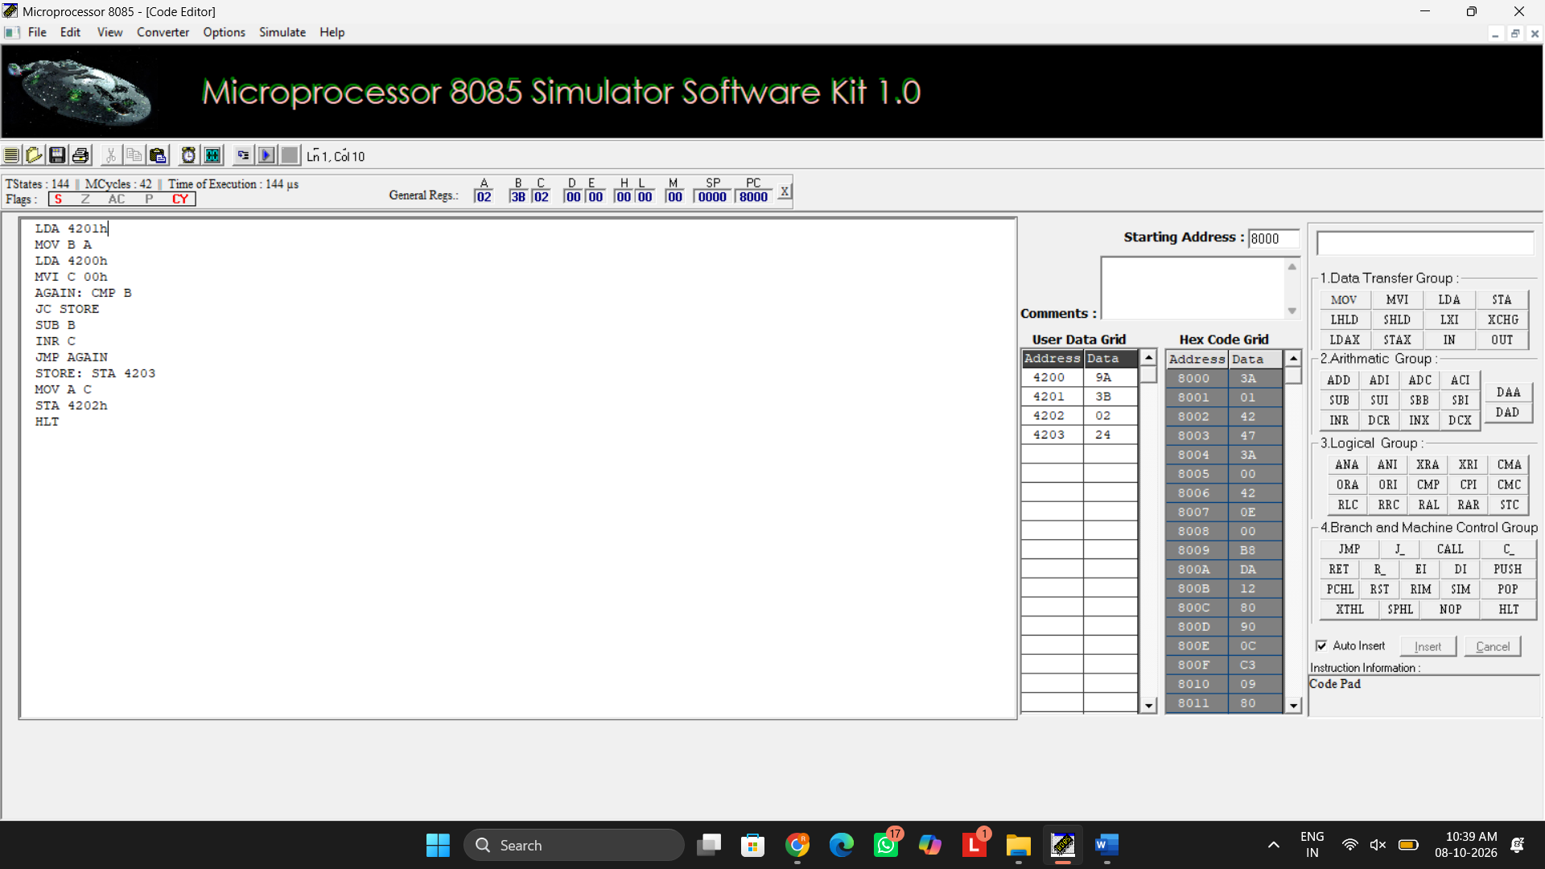

- verify assembly language programs for performing 16-bit addition and subtraction using the 8085 microprocessor and analyze the results obtained.

16 BIT ADDITION

LHLD 4200H
XCHG
LHLD 4202H
DAD D
SHLD 4204H
HLT

OUTPUT
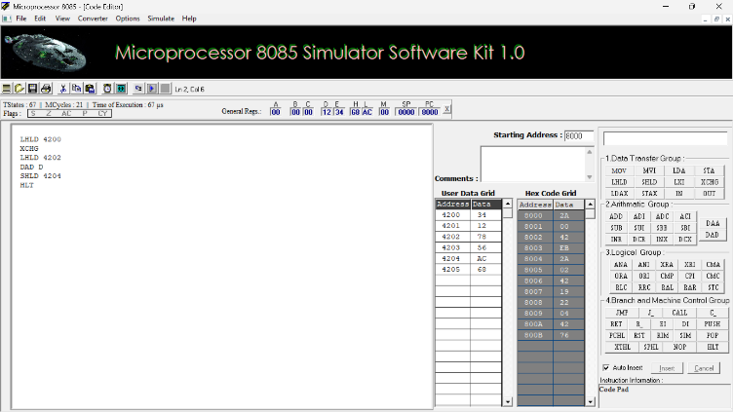
16 BIT SUBRACTION

LHLD 4200H
XCHG
LHLD 4202H
MOV A,L
SUB E
MOV L,A
MOV A,H
SBB D
MOV H,A
SHLD 4204H
HLT
OUTPUT
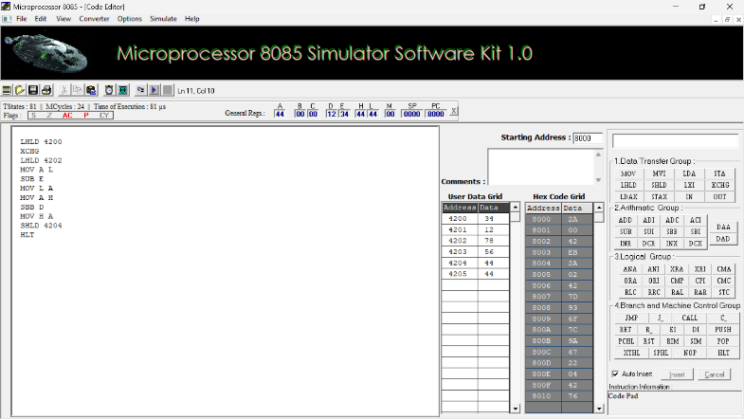

- verify assembly language programs for performing 16-bit multiplication and division using the 8085 microprocessor and validate the results obtained through memory locations.

16 BIT MULTIPLICATION
LHLD 2050H
XCHG
LHLD 2052H
MOV B,H
MOV C,L
LXI H,0000H
SHLD 2056H
MOV A,B
ORA C
JZ STORE
LOOP: DAD D
JNC NEXT
PUSH H
LHLD 2056H
INX H
SHLD 2056H
POP H
NEXT: DCX B
MOV A,B
ORA C
JNZ LOOP
STORE: SHLD 2054H
HLT

OUTPUT
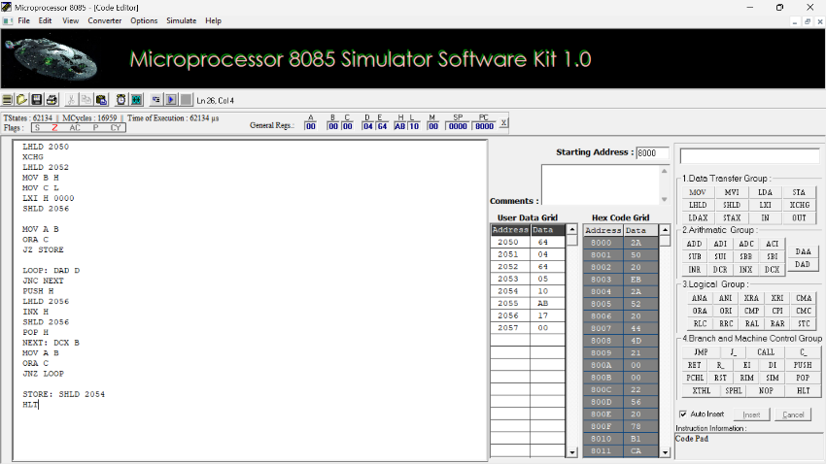

16 BIT DIVISION

LHLD 2050H
XCHG
LHLD 2052H
MOV B,H
MOV C,L
MOV A,B
ORA C
JZ STOP
LXI H,0000H
LOOP: MOV A,D
CMP B
JC DONE
JNZ SUBT
MOV A,E
CMP C
JC DONE
SUBT: MOV A,E
SUB C
MOV E,A
MOV A,D
SBB B
MOV D,A
INX H
JMP LOOP
DONE: SHLD 2054H
XCHG
SHLD 2056H
STOP: HLT

OUTPUT
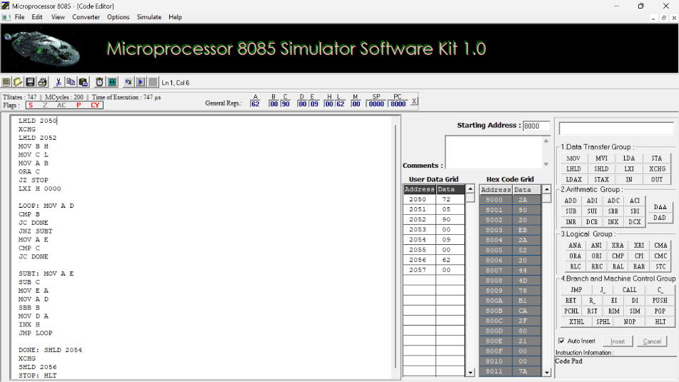

RESULT
Thus, the 8-bit and 16-bit arithmetic operations, including addition, subtraction, multiplication, and division, were successfully developed, executed, and verified using assembly language programs in the 8085 microprocessor simulator.

EXPERIMENT 02: LOGICAL, BIT-MANIPULATION AND SHIFT OPERATIONS USING 8-BIT AND 16-BIT DATA

Objective:
- To analyze, develop and verify logical AND, OR and XOR operations.
- To analyze, develop and verify one's and two's complement operations on 8-bit and 16-bit data.
- To analyze, develop and verify bit setting, clearing, toggling, rotate and shift operations.
- To verify the output results and carry flag using the 8085 simulator.

Components Required:
8085 Simulator

Procedure:
- Switch ON the 8085-microprocessor trainer kit.
- Enter the program opcodes at the specified starting memory address using the memory examine/substitute command.
- Store the required input data in the specified memory locations.
- Execute Program A from 4100H and Program B from 4200H using the GO/EXEC command.
- Examine the memory locations assigned for the output results and flag byte.
- Record the output values and verify them against the expected hexadecimal results.
- Repeat the procedure for both programs and record the observations.

  - Analysis of Logical Operations

PROGRAM [AND,OR,XOR in 8-bit ]
LXI H, 4500H MOV A, M INX H
MOV B, M ANA B PUSH PSW STA 4502H POP H MOV A, L STA 4509H LDA 4500H ORA B
STA 4503H LDA 4500H XRA B
STA 4504H HLT

OUTPUT
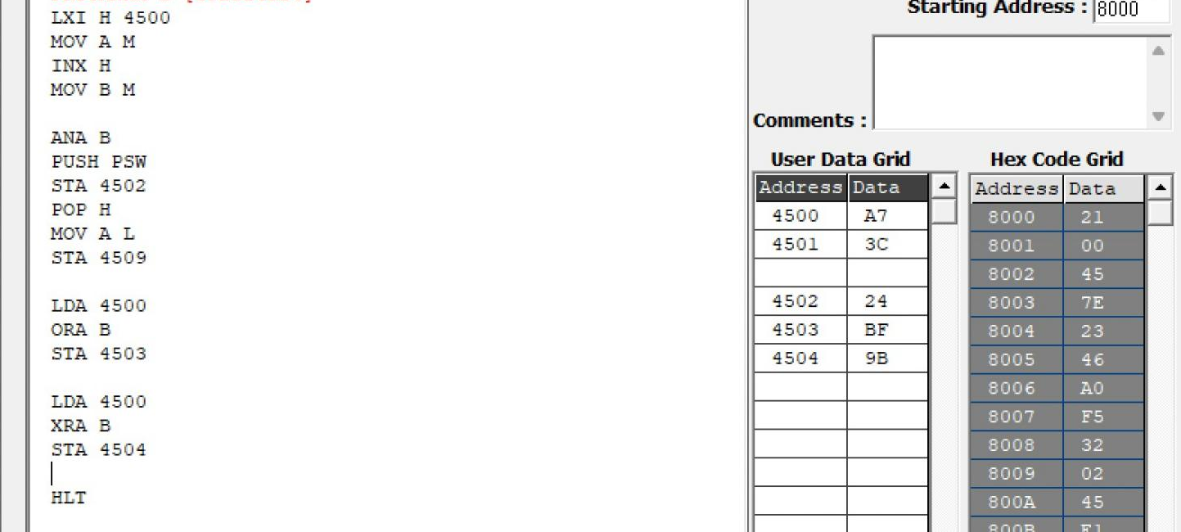

Memory | Data
4500H | A7H

4501H | 3CH
4502H | 24H
4503H | BFH
4504H | 9BH

PROGRAM [AND,OR,XOR in 16-bit ]
LDA 4500 MOV B A LDA 4502 ANA B STA 4504
LDA 4501 MOV B A LDA 4503 ANA B STA 4505
LDA 4500 MOV B A LDA 4502H ORA B STA 4506
LDA 4501
MOV B A LDA 4503 ORA B STA 4507
LDA 4500 MOV B A LDA 4502 XRA B STA 4508
LDA 4501 MOV B A LDA 4503 XRA B STA 4509 HLT

OUTPUT
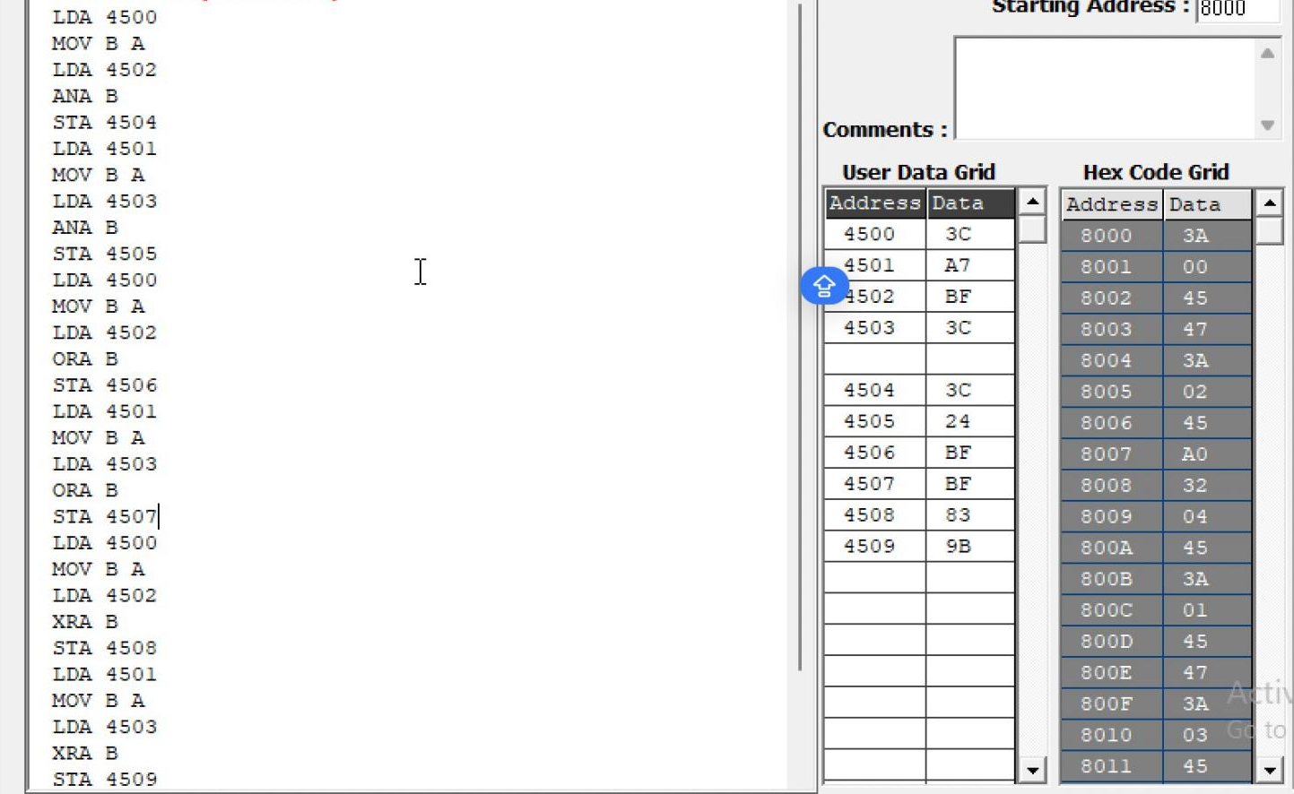

Memory | Data
4500 | 3CH
4501 | A7H
4502 | BFH
4503 | 3CH
4504 | 3CH
4505 | 24H
4506 | FFH
4507 | BFH
4508 | 83H
4509 | 9BH

  - Analysis of One's and Two's Complement

PROGRAM [16-bit]
LDA 4500H ANI 0FH STA 4505H LDA 4500H ANI F0H STA 4506H LDA 4500H CMA
STA 4507H INR A
STA 4508H
LHLD 450AH MOV A, L CMA
MOV L, A
MOV A, H CMA MOV H, A
SHLD 450CH INX H
SHLD 450EH HLT

OUTPUT
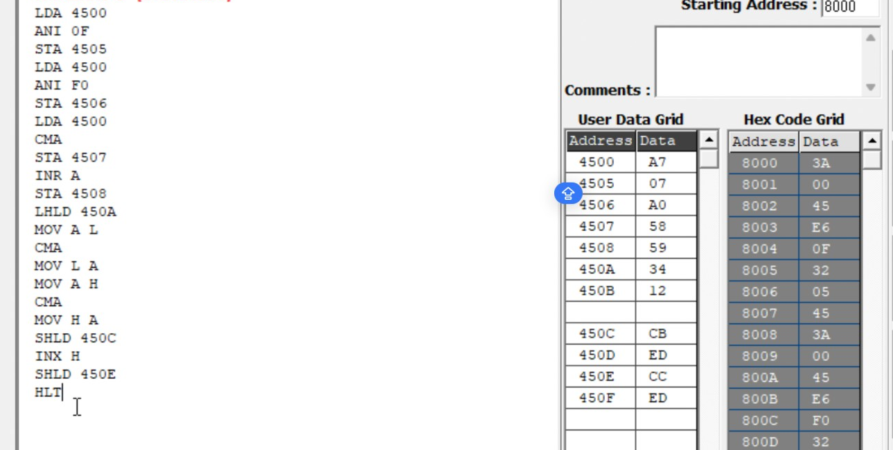
Memory | Data
4500 | A7
4505 | 07
4506 | A0
4507 | 58
4508 | 59
450A | 34
450B | 12
450C | CB
450D | ED
450E | CC
450F | ED

  - Analysis of Bit Setting, Clearing, Rotate

PROGRAM [Bit Manipulation]
LDA 4510H ORI 81H STA 4511H LDA 4510H ANI F5H STA 4512H LDA 4510H XRI 0FH STA 4513H MVI C, 00H LDA 4510H ANI 40H
JZ NEXT INR C
NEXT: MOV A, C
STA 4514H LDA 4510H RLC
STA 4515H LDA 4510H RRC
STA 4516H LDA 4510H ORA A
RAL
STA 4517H LDA 4510H ORA A
RAR
STA 4518H LDA 4510H MOV B, A RAL
MOV A, B RAR
STA 4519H LDA 4510H MVI B, 08H MVI C, 00H CNT: RLC

JNC SKIP INR C
SKIP: DCR B JNZ CNT MOV A, C STA 451AH HLT

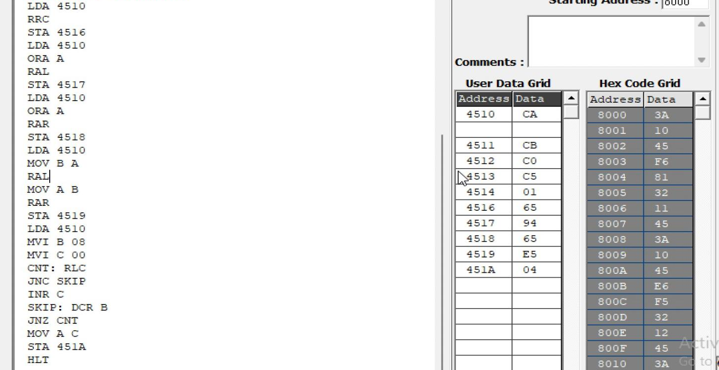
OUTPUT

Memory | Data
4510H | CAH
4511H | CBH
4512H | C0H
4513H | C5H
4514H | 01H
4515H | 95H
4516H | 65H
4517H | 94H
4518H | 65H
4519H | E5H
451AH | 04H

  - Analysis of Shift Operations

PROGRAM [16-bit Shift Left]
LHLD 4520H DAD H
SHLD 4522H HLT

OUTPUT
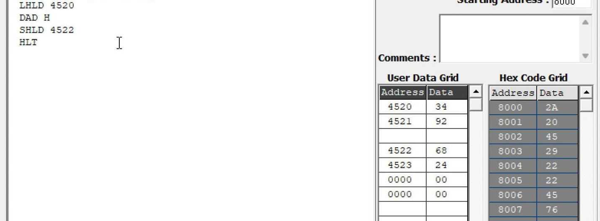

Memory | Data
4520H | 34H
4521H | 92H
4522H | 68H
4523H | 24H

Result:
Thus, the logical, bit-manipulation, complement, rotate and shift operations were performed using the 8085 simulator. The output values were examined in memory and verified against the expected hexadecimal results.

EXPERIMENT – 3 Multi-Byte Data and Array Operations Using 8086 Indirect Addressing
Objectives of this Experiment:
1. To add two numbers using register-indirect and based addressing.
2. To find the sum of N 16-bit numbers stored in a word array.
3. To add two 64-bit numbers byte by byte with carry propagation using a loop.
2. To find the sum of N 16-bit numbers stored in a word array.
1. Program

8086 program
MOV SI, 2000H
MOV CX, 0005H
MOV AX, 0000H
NEXT: ADD AX, [SI]
ADD SI, 02H
LOOP NEXT
MOV [2010H], AX
HLT

2. Data Input (Memory)
Memory
Address Data
2000H 1234H
2002H 2345H
2004H 1111H
2006H 2222H
2008H 3333H

3. Output
Register / Memory Address Output
AX 9BDFH
2010H 9BDFH
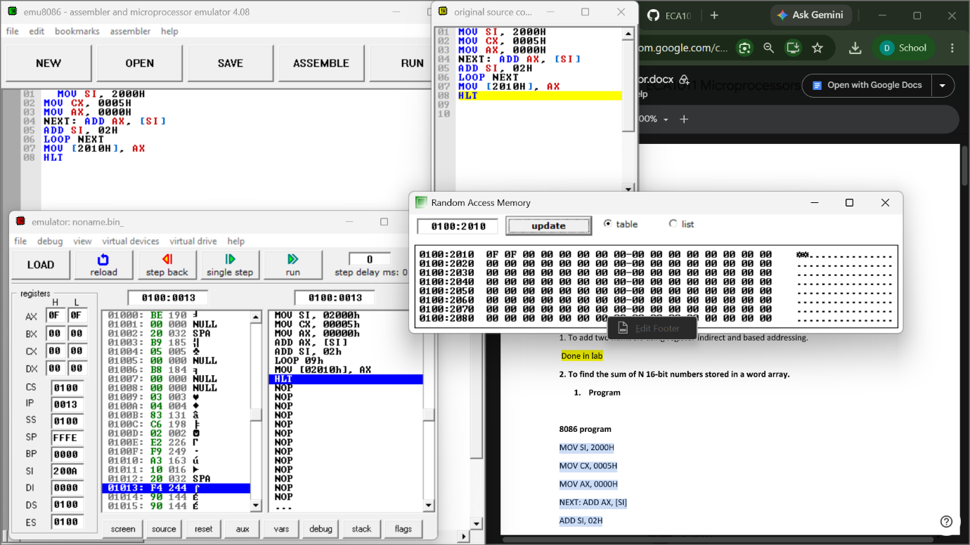

3. To add two 64-bit numbers byte by byte with carry
propagation

8086 Program – Addition of Two 64-Bit Numbers
Starting Address: 1100H
Program
MOV SI, 2000H
MOV DI, 2008H
MOV BX, 2010H
MOV CX, 0008H
CLC

NEXT: MOV AL, [SI]
ADC AL, [DI]
MOV [BX], AL
INC SI
INC DI
INC BX
LOOP NEXT

MOV AL, 00H
ADC AL, 00H
MOV [2018H], AL

HLT
Input Data

First 64-bit Number
Addres
s
Dat
a
2000H 12H
2001H 34H
2002H 56H
2003H 78H
2004H 9AH
2005H BCH
2006H DEH
2007H F0H
Second 64-bit Number
Addres
s
Dat
a
2008H 11H
2009H 22H
200AH 33H
200BH 44H
200CH 55H
200DH 66H
200EH 77H
200FH 88H
Output Data
Addres
s
Resul
t
2010H 23H
2011H 66H
2012H 89H
2013H BCH

2014H EFH
2015H 64H
2016H 95H
2017H 79H
2018H 01H
Final Result:
179564EFBC896623H
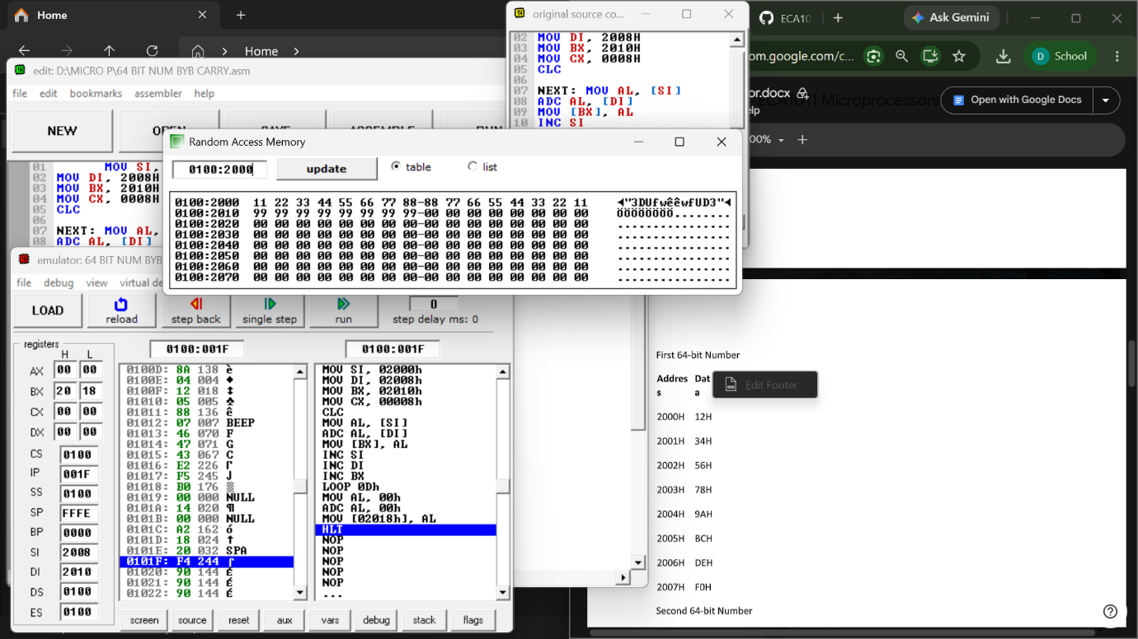

EXPERIMENT – 4 String and Block Data Operations Using 8086 Microprocessor

Objectives
1. To transfer a block of bytes using MOVSB with the REP prefix, including an overlapping block move
controlled by the direction flag.
2. To compare two strings using CMPSB with the REPE prefix and locate the first mismatch.
3. To search a string for a character using SCASB with the REPNE prefix and count its occurrences.
4. To process a string element by element using LODSB and STOSB (lower-case to upper-case
conversion).

Program A – Block Transfer with REP MOVSB

1000 CLD
1001 MOV SI, 3000H
1004 MOV DI, 3100H
1007 MOV CX, 000BH
100A REP MOVSB
100C HLT

Output
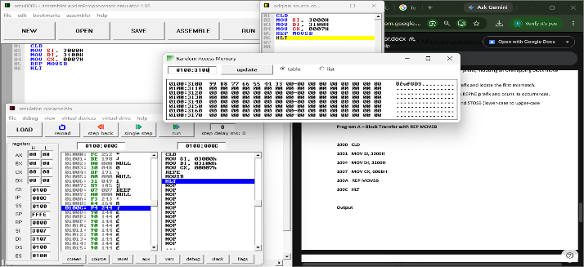
Program B – String Comparison with REPE CMPSB

1100 CLD
1101 MOV SI, 3200H
1104 MOV DI, 3210H
1107 MOV CX, 0003H
110A REPE CMPSB
110C JNE DIFF
110E MOV BYTE PTR [3220H], 00H
1113 HLT
1114 DIFF: MOV AX, 0003H
1117 SUB AX, CX
1119 MOV [3220H], AL
111C HLT
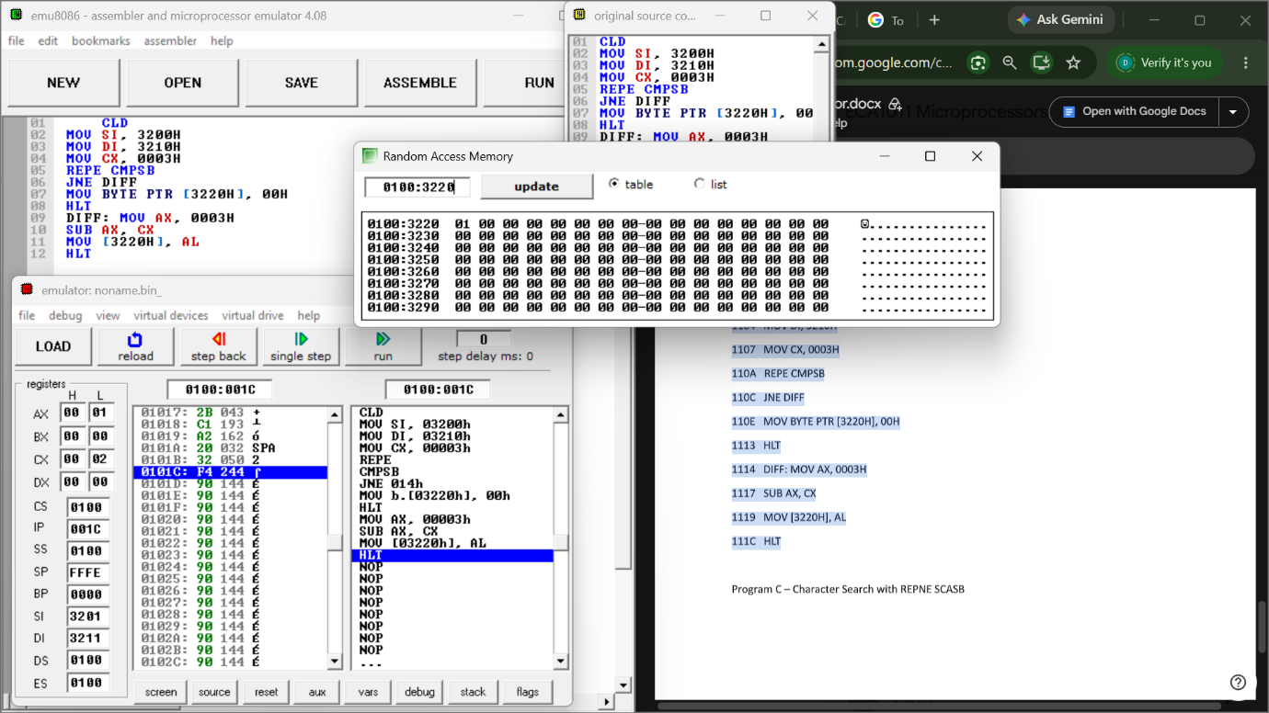

Program C – Character Search with REPNE SCASB (start address 1200H)
Algorithm
1. Clear DF; point DI to the string; CX = length; AL = character; clear the counter and
position.
2. Execute REPNE SCASB; if not found, go to step 4.
3. Increment the count; record the first position (DI − start); if CX ≠ 0 repeat step 2.
4. Store the count and the first position; halt.
Program / Coding Table

MOV DI,3300H
MOV CX,000CH
MOV AL,41H
MOV BL,00H
MOV DX,0000H
AGAIN:REPNE SCASB
JNE DONE
INC BL
CMP DX,0000H
JNE SKIP
MOV DX,DI
SUB DX,3300H
SKIP:JCXZ DONE
JMP AGAIN
DONE:MOV [3310H],BL
MOV [3311H],DL
HLT

OUTPUT

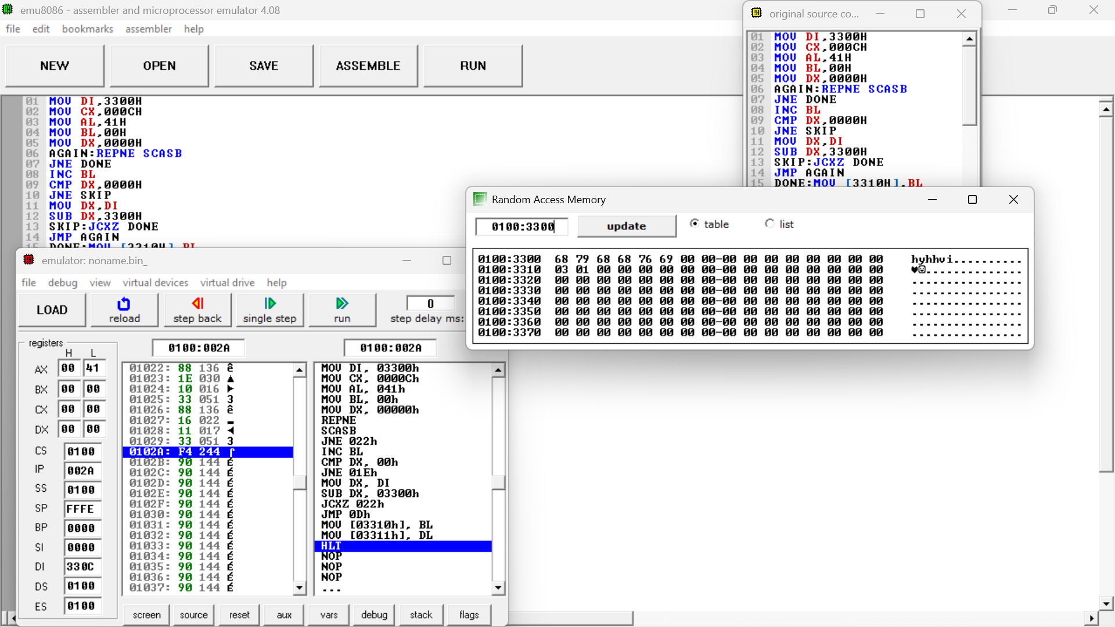

Program D – Lower-case to Upper-case Using LODSB / STOSB (start address 1300H)
Algorithm
1. Clear DF; point SI to the source and DI to the destination; CX = length.
2. LODSB loads a character; if it lies between 61H and 7AH subtract 20H.
3. STOSB stores the character; LOOP until CX = 0.
4. Halt.

PROGRAM

MOV SI,3400H
MOV DI,3420H
MOV CX,000AH
CLD

NEXT: LODSB
CMP AL,61H
JB STORE
CMP AL,7AH
JA STORE
SUB AL,20H

STORE: STOSB
LOOP NEXT

HLT
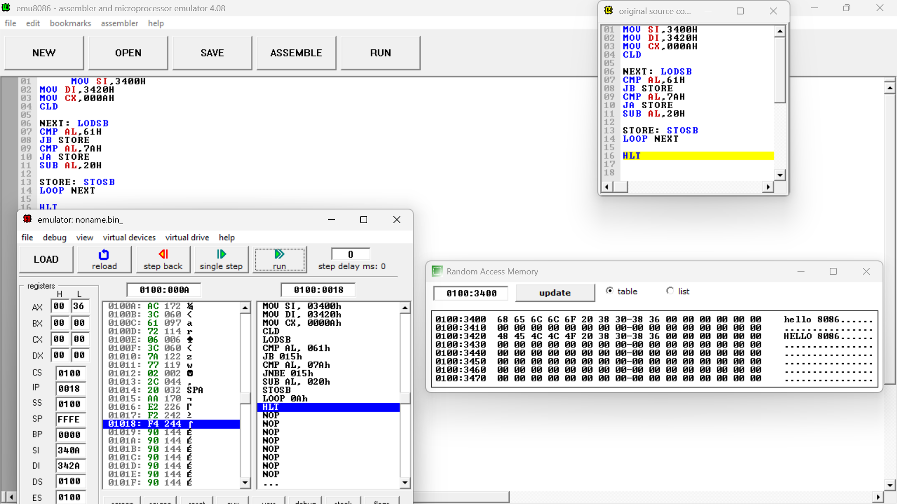

RESULT:
Thus, the 8086 microprocessor string and block data operations were successfully executed. Block transfer using REP MOVSB, overlapping block movement using the direction flag, string comparison using REPE CMPSB, character searching using REPNE SCASB, and lowercase-to-uppercase conversion using LODSB and STOSB were performed successfully, and the expected outputs were obtained in the specified memory locations.

